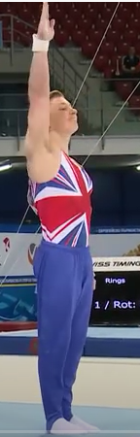
Gymnastics Competition Judging Sheet

- Present
First move should be a present to begin the routine, Girls would present with two arms raised and boys would present with one arm. Either present from any gymnast is acceptable.

- Shape
The second move should represent one of the gymnastics shapes.
All shapes must be held for 3 seconds.
a, Straight,
b..
a.

b, Star
c.

c, Tuck
da.
d, Dish
e.
e, Arch
f.
f, Pike sit
g.
g, Straddle Sit
h.
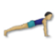
h, Front support

B.
A.
- Roll
Rolls must travel along the mat.
A, Pencil roll – sideways straight roll.
C.
B, Egg roll – Sideways tucked roll
.
C. Tucked roll – forward roll that stays in a tucked position throughout, doesn’t have to finish with a standing position.
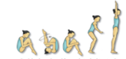
D. Rock back to Stand – crouch, rock back to the shoulders and then stand with feet together.

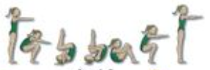
E- Forward roll to seat – Start with a crouch and reach forward in to the roll, Finish the roll in a seated postion.

D, Forward roll – Start with a crouch and a reach forward, attempt to straighten the legs through the roll, finish in a standing position.
D.

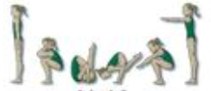
E, Backward Roll – Crouch, rock on to the shoulders, hands push against the floor and take the legs over the head. Finish in a crouched or standing position. Must not roll over the shoulder.
Ei.

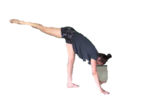
- Three Point Balance
This is a balance with three parts of the
body touching the floor.
For example, two hand and one foot,
one knee, one foot and one hand.
Head and two hands, ect.

- Travel over 2m
This must move from one end of the mat to the other, this could be performed on the floor is more space is needed.
Hop – only one foot contacts the ground.
Skip
Hop scotch – one foot, two foot jumps, can land on alternate legs to increase challenge.
Gallop (chasse) – travelling forwards not letting the feet cross.
Side chasses – side stepping without letting the feet cross.
Side Chasse Pivots – After each side step, turn around to change the leading leg.
Skip Backward
Change leg chasse – Forward gallops, after each gallop change the leading leg. (see video)

- Jumps
Bi.
Ai.
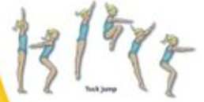
All jumps must land with control,
A, Straight jump
Ci.
B, Tuck Jump

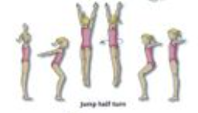
C, Star Jump
Di.
Ei.
D, Half turn jump

E, Half turn tuck jump
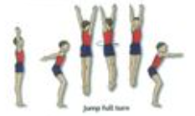
Fi.
F, Full turn
G – F with tuck jump.
G, Full turn Tuck

- Final Present
A final present should be made at the end of the routine.

How to score
The score sheet is ticked for each move that is displayed during the routine.
If both presents are included then they score one point for presentation.
If the moves are performed in order they score one point. The gymnast may have failed one move but as long as it was attempted in order this would still score.
If they perform the routine without any prompts they score one point.
General impression – Gymnasts can score up to a maximum of three points for general impression, or how much they look like a gymnast.
The lowest score would be one point.
A gymnast that demonstrates stretch of hands and feet during just the moves would score two points.
A gymnast that continues to hold their stretch throughout the entire performance would score three points.
There is no score awarded for the gymnastics skill element.
Suggested scorers
A minimum of two judges required.
One judge to mark the sequence of moves and one judge to mark the move quality and bonus scores.
These roles could be delegated to young leaders, with a leader for each move including one for presentation, order and prompts.
The general impression could be marked by an audience (class members)

