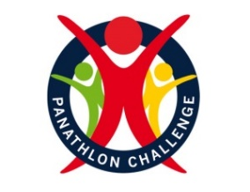

Entry Form: Primary Schools & Primary SEN resource units

Please complete the following form to indicate your interest in the new virtual Panathlon Discovery events, giving approximate entry numbers for your specific school or specialist unit. Upon receipt of your entry Panathlon will send video clips for each activity, rules, score sheets and monitoring forms.

School/Unit name and address include (County)

Your School Games Organiser

Contact name & number
Email address
Activity | Results | Rewards | Monitoring | Entry Numbers
Pre-season  Multi-skills Primary | No submission of results | Schools receive certificates and stickers (max 50) plus extra pdf certificates to print | Schools return completed form | Competitors | Leaders
Multi-skills  Game Day Primary | Results need to be sent in by 9 December 2020.  Results will be placed in a Panathlon primary league table | SEN children will receive a medal and certificate  (Max 20 per school) Additional pdf certificates  Top SEN teams in the county will be awarded trophies and team certificates | Schools return completed form | Competitors | Leaders

Game Days
Activity | Results | Rewards | Monitoring | Entry Numbers
10 Pin Bowling | Results need to be sent in by 31 January 2021  Results will be placed in a Panathlon ‘category’ school league table | Every SEN child in will receive a medal and certificate (max 20)  Additional pdf certificates | Schools return completed form | Competitors | Leaders
New Age Kurling | Results need to be sent in by 31 January 2021  Results will be placed in a Panathlon ‘category’ school league table | Every SEN child will receive a medal and certificate (max 20)  Additional pdf certificates | Schools return completed form | Competitors | Leaders

Please return your entry form to entries@panathlon.com

