Virtual Multi-Skills Competition – 2020/2021
Please see below details of the Summer School Games Virtual Multi-Skills competition, with separate competitions for boys and girls.
Designed to help support and promote activity, health and well-being for all students across the whole school, inclusive so that all students are able to take part at their own level and provide them the opportunity to develop and improve personal skills and techniques. The challenges also provide a focus on School Games Values of Determination and Self-Belief.
These resources are flexible and if you wish can be adapted and used just internally to suit your school; this could be with a handful of students or a full year/key stage. If you wish to enter the Inter School Competition please follow the rules below as closely as possible.
Safety
- Area to be risk assessment by school staff
- Minimal use of equipment which could be cleaned after use
- Social distancing should be maintained at all times
Rules and Format
- Taking place at the individual schools that are participating with each school devising their own schedule. This could be during PE lessons, After School Clubs or in a Specific Competition Schedule within school
- We will collate results for Y1/2 combined, Y3/4 combined and Y5/6 combined group for both genders. See further detail below for results
- Students will compete in four separate challenges scoring points within each challenge to provide a total.
- Each student should have two attempts to create their best total, preferably with some practice in between attempts as we will also be recording the highest improvement.
Leadership
- In school young leaders could be utilised to co-ordinate and run each challenge station, monitoring participants, maintaining safety, timing, scoring and recording results.
Recording Results
- We need you to send us the following results by 4th December latest, by e-mail to simon.jones@whgs-academy.org
- Please submit your top three scores forY1/2, Y3/4 and Y5/6, boys and girls separately.
- Please also submit your top three most improved scores for Y1/2, Y3/4 and Y5/6, boys and girls separately.
- Please also record and submit the total number of, girls and boys separately, that have taken part.

- Top scoring students and most improved score students will be presented with prizes at the end of the competition
We would request that every school competing to post at least 1 picture/video on Twitter @mcrschoolspe #TeamManchester. This isn’t compulsory, it’s purely as means to evidence that it is happening and gives us something simple that can be collated (for you and us) that evidences that good practice is taking place across Manchester.

Challenge One – Space Shuttle (10m Shuttle Run)
- Equipment, flat markers / cones, stopwatch
- Place the 2 markers/cones 10m apart
- Each person has 30 seconds to complete as many shuttle runs between the two cones
- Each completed shuttle counts as 1 run which is worth 5 points. Students must reach the marker/cone at both ends each shuttle. Only fully completed shuttles to count when the time is up
Challenge Two – Balance
- Equipment, marked line on the floor stopwatch
- Placing one foot on a marked line, on the word go raise the other leg off the ground
- Stop the watch when the student moves their standing foot off the line, or touches the ground with their other foot or the time elapses
- KS1:- Each student has to balance on one leg for up to a maximum of 30 seconds
- KS2:- Each student has to balance on one leg for a maximum of 60 seconds
- Points scored KS1 – 1 point for every second balanced (ie. 24 seconds = 24 points)
- Points scored KS2 – 1 point for every two seconds balanced (ie. 24 seconds = 12 points, round down so 25 seconds also = 12 points)
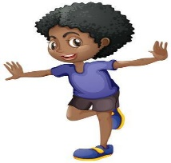

Challenge Three – Bop It (Hop, Skip & Jump)
- Equipment: flat markers/cones, stopwatch
- From a start/finish line mark out three 5m lines, on the word go participant should hop the first 5m, then skip from 5m – 10m and jump from 10m – 15m (once across counts as 5 points), participant should then turn round and repeat on the way back, hop, skip, jump. Keep going until the 45 seconds is up, only completed crosses should count.
- Each person has 45 seconds to get across and back as many times as possible
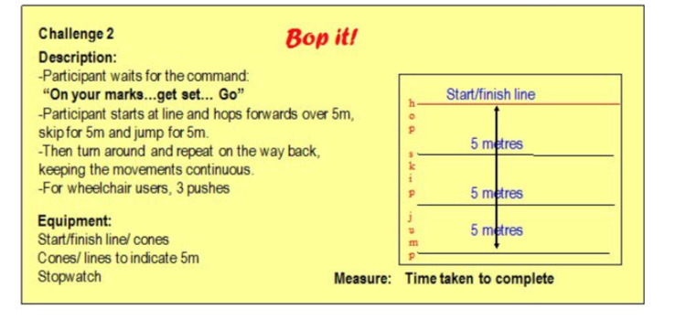

Challenge Four – Hoopla (Target Throw)
- Equipment, flat markers/cones, 5 hoops, 5 bean bags (bean bags could be replaced by balls)
- From a throwing line each participant has 5 attempts to throw their bean bags underarm (one at a time) into target hoops laid on the floor
- From the throwing line 2 hoops should be 2m away, 2 hoops should be 3m away and 1 hoop 5m away
- Points scored for bean bags landing in the hoop:- 2m away – 1 point / 3m away – 3 points / 5m away – 5 points
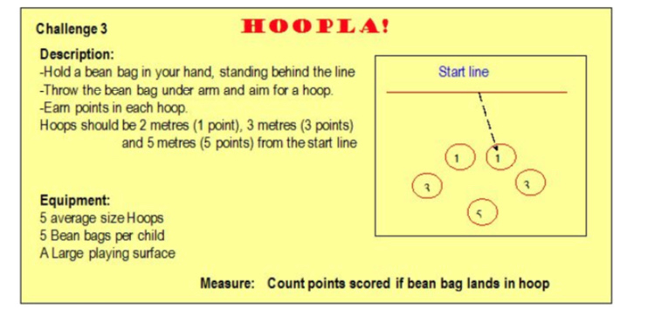

All of these exercises can be adapted to suit your students, increasing or decreasing the distance, time, use balance beam etc. These could then be used for Personal Challenges or as Intra School competition/activity.
If you wish to enter results for the Inter School Competition then please follow the guidelines for each challenge as closely as possible.

