MANCHESTER BOYS U14’s- GREATER MANCHESTER LEAGUE CHAMPIONS!!

Jack Sadler Parrswood (RB)
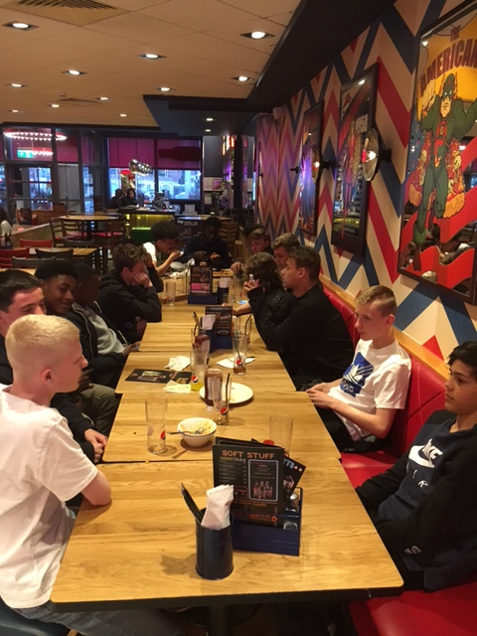
Vani Da-Silva Wright Robinson (LW)
Kevin Spinelli Wright Robinson (FW)
Louie Bull Our Lady’s (CM)
Luiz Martinez Chorlton (GK)
Leo Brookfield-Paul Chorlton (CM)
Niall Rouse-Douglas Chorlton (CM)
Louie Clarkson (vice-captain) Man Co-operative (CM)
Mustafa Nadjafi Manchester Academy (CB)
Enoch Takpe Trinity (RW)
Cameron Beresford Trinity (RB)
Luke Matherson (captain) Trinity (CB)
Ebe Mbachu Trinity (LW)
Michael Maguire Loreto (CB/CM)
Dylan Gwyther St. Paul’s (LB)
Joesph Okergera MGS (RW)
Will Fitchew MGS (GK)
Denzil Duncan TEMAC (GK)
Josh Harrision St. Matthew’s (CM)
David Abubakar St. Matthew’s (CB)
End of season celebratory meal at Pizza Hut
Zidane Iqbal WHGS (CM)
Lewis Boyd WHGS (LW)
Zaid Smith WHGS (RW)

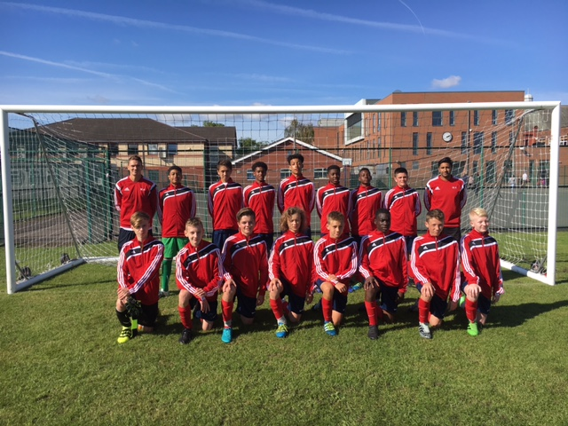

Squad photo before our first fixture of the season- an 8-0 win at home vs Stockport
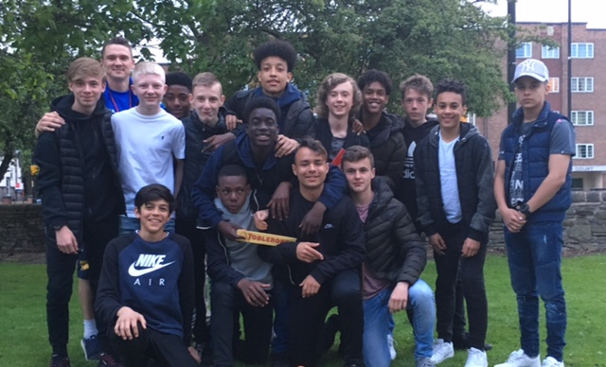

Post end of season meal picture- ready to challenge for the nationals next year!

Results:
Stockport 8-0 W (H- league)
Bury Academy 2-2 D (H- friendly)
Salford 3-1 W (A- league)
Liverpool 2-0 L (A- North West Cup)
Tameside 3-0 W (H- league/league cup double header)
Salford 1-0 L (A- league cup)
Tameside 3-2 W (A- league)
Stockport 3-2 W (A- league)
Bolton 4-2 W (H- league)
Trafford 3-0 W (H- league)
Wigan 3-2 W (H- league double header)
Salford 2-2 D (H- league)
Bolton 1-0 L (H- league)

