



Martin Wright

School Games Organiser

Mob: 07565 525 121

Email: martinwrightcompetitionmanager@googlemail.com

Dear Colleague

Re: Manchester Primary Quadkids Championships

Thursday 7th July 2016 at Eastlands Athletics Stadium, from 2.00 – 4.00pm

(Warm-Up and registration from 1.30pm)

I would like to invite you to take part in the Manchester Schools’ Quadkids Championships.

* Registration and warm-up will be from 1.30pm
* The event will start at 2.00pm and finish at 4.00pm.
* A team will consist of 6 boys and 6 girls from Year 5 / 6. Each individual will take part in all the track and field events, however, only the best 4 scores (out of the 6) will count towards your team score

The events are as follows:

* 75m sprint
* 600m
* Standing Long jump
* Vortex Howler throw

If you would like to enter this event, please complete the Team Declaration Sheet and return it by:

Friday 24th June

Please note: All entries must be via by the Team Declaration Sheet, which is attached - if you do not know which athletes will be competing yet, please enter online at <http://www.manchesterschoolspe.co.uk> with the number of teams you would like to bring - remember: 6 boys and 6 girls per team.

Medals will be awarded for:

* The first 3 teams in the competition
* The top 3 boys - combined events scores
* The top 3 girls - combined events scores

The top 2 schools will represent Manchester in the GM Level 3 Finals @The Radclyffe School, Oldham on Wednesday 13th July 2016, from 1.30 – 4.00pm.

Should you require any further information in the meantime please contact me on the mobile.

Yours sincerely

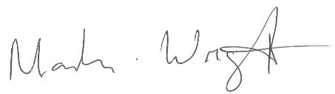

Martin Wright

School Games Organiser

07565 525 121

