



Martin Wright

School Games Organiser

Mob: 07565 525 121

Email: martinwrightcompetitionmanager@googlemail.com

City of Manchester Schools’ Track & Field Championships 2016

Year 7

In partnership with Manchester Sports Development, Manchester Schools AA, Manchester Schools’ PE Association and Sale Harriers.

Wednesday 22nd June 2016 at Manchester Regional Arena, Eastlands.

**12.30pm registration : 1.00pm start : finish at approximately 4pm.**

1 Athlete per event, each athlete can do 1 event plus a relay

**EVENTS:**

100m Shot Putt

200m Discus

800m Javelin

1500m Long Jump

4x 100m Relay High Jump

1 Athlete per event, each athlete can do 1 event plus a relay

**By entering this competition, you are agreeing to provide 1 official / young leader to assist with the delivery of events on the day.**

See separate attachments for the events and entry form

***Please note that all track events will run as time-trials on the day.***

There is a non-scoring 70m Hurdles Championships for Boys and for Girls. This will be run as a time-trial and should only be for those athletes who are experienced Hurdlers.

PLEASE do not enter any athlete who is not a capable performer.

Yours sincerely

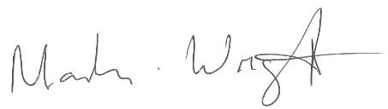

Martin Wright

School Games Organiser

07565 525 121

